How to dispose of your rubbish at Tan y Castell.

General Household Waste (Green Bin) is collected every 3 weeks by the local council. As people stay at various times in the house putting black bins bags into the Green Bin for future collection often results in the bags being left for months – rotting – as the Green Bins are not regularly and reliably put out for collection.

Please don’t use the Green or large Brown bin (Garden Waste).

**This is what you have to do:**

Please separate your normal household rubbish from your food waste.

You can put everything (except nappies/food waste) into black bin bags for disposal/separation at the local recycling centre. Remember you may need to hand separate the black bin contents when you get to the recycle centre so wash the jars/food trays etc.

The food waste needs to be put into the biodegradable light green sacs (kept under the kitchen sink). These thin biodegradable sacs are lining for the small brown bin/caddy in the kitchen. As the small brown caddy fills you can then remove the sacs to the slightly large brown caddy (in the garage) – this is NOT the large brown wheelie bin outside.

We suggest that you keep any filled black bin bags with household waste inside the garage (to avoid foxes/rats/badgers). When you leave the house please take all the black bin bags, food waste and any other rubbish that can be recycled to the recycling centre which is 3.2 Km (less than 2 miles) from Tan y Castell. See map and photos below. Enter 52°53'02.9"N 4°06'41.7"W in Google Maps or this link: <https://goo.gl/m5fjW6>

The recycling centre will take Nappies, but please keep them separate from the food and general waste.

When you go to the recycling centre it is possible you may be asked to open black bags and sort waste for recycling before disposing any material in the household waste skip. There is a small cabin which lets you sort through this general waste and separate it out to tins/plastic/glass/cardboard etc. Take some disposable gloves with you. Next to the cabin there is a large brown bin for your food waste.

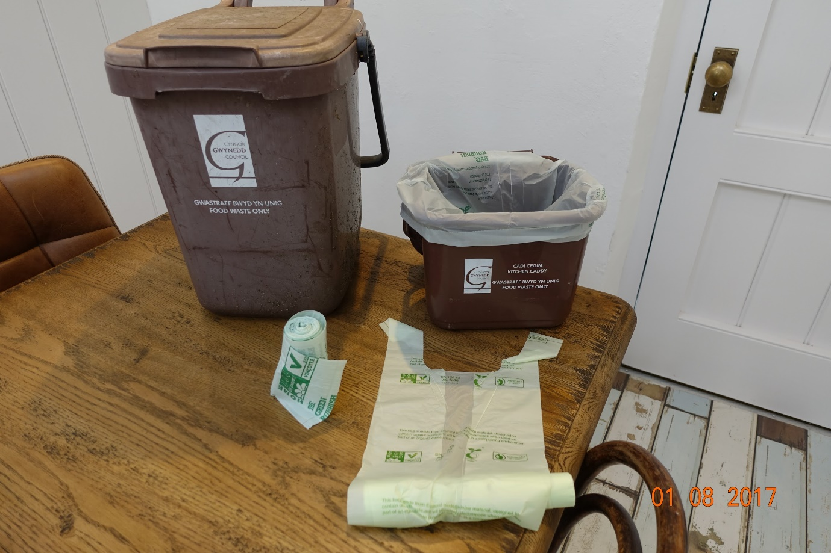

<https://www.gwynedd.llyw.cymru/en/Residents/Bins-and-recycling/Bins-and-recycling.aspx>

Harlech Recycling Centre LL46 2UW

Opening hours

Monday - Friday 10:00 - 16:00

Saturday - Sunday 10:00 - 15:00

What can be recycled at the centres?

The sites accept a wide range of household waste for recycling, such as:

• Scrap metal

• Wood and timber

• Mattresses

• Garden waste

• Rubble

• Cardboard

• Paper

• Plastic – bottles, pots, tubs and trays such as yogurt and butter pots

• Hard Plastics – such as old toys or garden furniture

• Food & drink cans

• Glass bottles and jars

• Beverage containers

• Textiles

• Gas bottles

• Household and garden chemicals

• Paint

• Vegetable oil

• Used engine oil

• Tyres

• Batteries

• Car batteries

• Carpets

• Food waste

• Fluorescent tubes

• Televisions

• All sort of electrical equipment

• Fridges

• Freezers

Further information is available by contacting

Gwynedd Council on 01766 771000 or [recycling@gwynedd.gov.uk](mailto:recycling@gwynedd.gov.uk)

